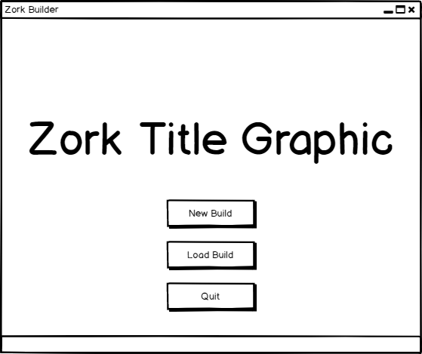

Clicking on either New or Load Build will bring up a typical windows file explorer menu.

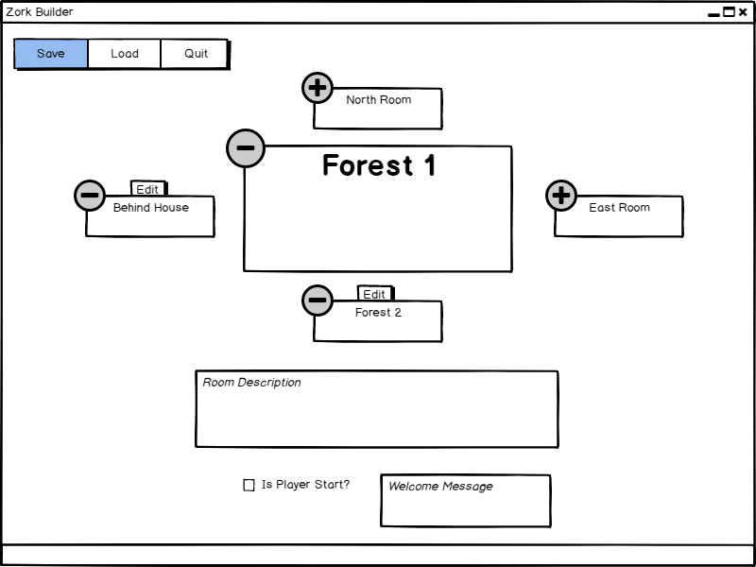

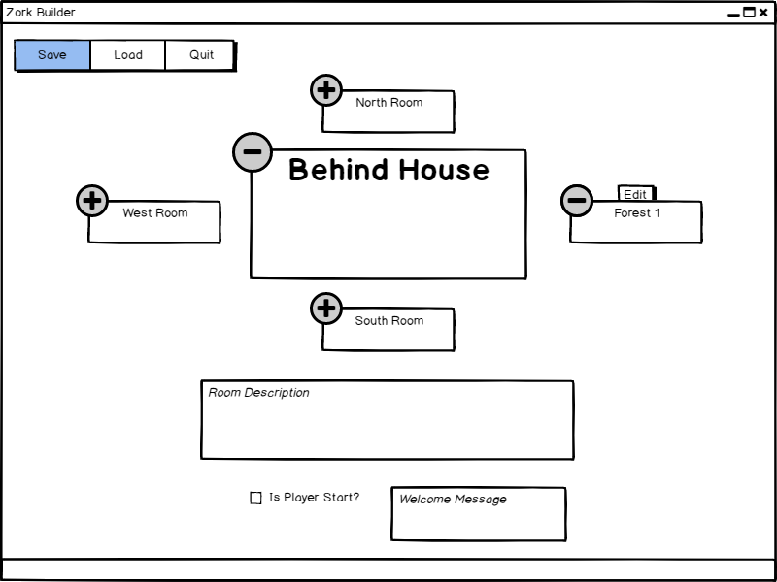The currently selected room is displayed as the larger, middle box, and the name of the room can be changed by clicking on its current name (Forest 1 in this case). Rooms can be added by clicking on the ‘+’ icon and removed by clicking on the ‘-‘ icon. Rooms can be edited by clicking on the edit button above the room’s box, which will switch the viewport to that room (example below).